WIZnet iEthernet Design Contest 2007
Entry number 001185
Chuck Baird, service <at> cbaird.net

Abstract

Terminalator II – The SQL

Abstract
This project (001185) uses a WIZnet WIZ810MJ board and an Atmel AVR Butterfly development board to connect a PC host server application to a “dumb” ASCII terminal. The user at the terminal inputs SQL commands which are applied to a Microsoft Access database, and the results are displayed on the terminal.
The Butterfly is based on an 8MHz ATmega169 MCU with 16K flash, 2K SRAM, 512 bytes EEPROM, 4MB dataflash, 6 character LCD, joystick, RS-232 level converters, and other peripherals. The LCD is used to display status information about the ethernet connection. The WIZ810MJ board is accessed using its SPI mode, given the Butterfly has an SPI header readily available.
When the Butterfly is powered on it attempts to initialize the WIZnet board and make a client connection to the host software running at specified IP address. Once the connection is made, the user is free to type SQL statements on the terminal. Most of these statements are passed directly to the database, so the user might as well be juggling scimitars blindfolded.
The Atmel AVR Butterfly was chosen because of its low price (under $25) and complement of existing support circuitry, thus allowing the entire project to be constructed from off the shelf components and a wiring harness. However, because of design consistency across the AVR product line, the project could easily be ported to the majority of the AVR microcontrollers with very minimal changes to the software.

Block Diagram
Because of the slightly unusual spacing of the header pins (2 mm) on the WIZ810MJ, an inexpensive SPI breakout board was purchased from www.nkcelectronics.com. This board, fully populated, also provided a reset switch, power LED, and LEDs for the 5 status signals, all with pullup resistors. The SPI and other signals are brought out to a more convenient 0.1” header.

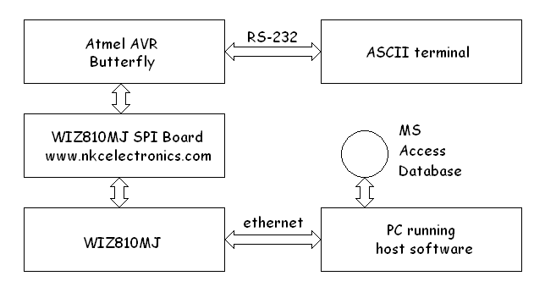
Block diagram

Photograph
The photograph shows the commercial components luxuriously mounted to prevent electrical shorts and facilitate handling. The wiring harness extends below the visible surface.
The 6 pin header in the Butterfly’s lower right corner is both its SPI and programming header (AVRs use the SPI pins for one of several methods of programming). To program the Butterfly with this application this connector is temporarily replaced with one to the programming hardware. An Atmel STK500 programmer was used, although many alternatives exist.

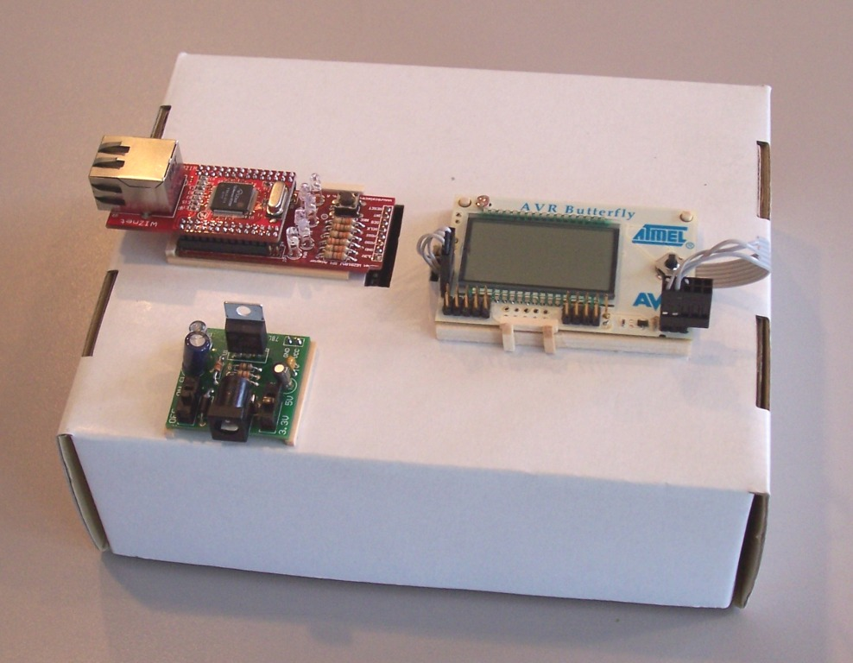
Yet another use for recycled cardboard

Clockwise, from upper left: WIZ810MJ (on top) plugged into the breakout/carrier (bottom) board, the Atmel AVR Butterfly, and the Sparkfun Breadboard Power Supply. The RS-232 connection to the terminal is in the rear and not visible.

Schematic
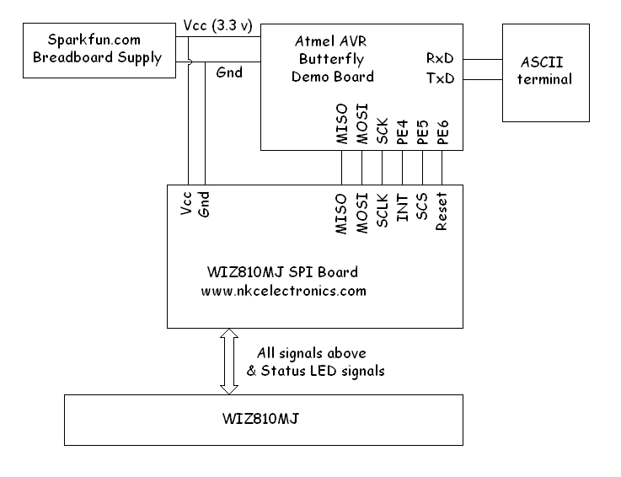

Software Code Example
Assembly language was used in the AVR because the author is a masochist. With the exception of the LCD segment layout table, all code is original, although pieces have been borrowed from other of the author’s projects, some published, including another WIZnet iEthernet Design Contest entry. Visual Basic 6 was used for the PC host software.

; ------------------------------------------------------
; recv_read - read from W5100 receive buffer, socket 0
;
; z - where to put returned values (SRAM address)
; r16 - maximum bytes to read (1 - 255)
; returned as bytes read (may be zero)
;
; note: z is returned pointing at next available location,
; so multiple calls may be made to concatenate data

recv_read:
tst r16
brne rok ; yes, a skip on the flags would be better
ret ; request for zero bytes

rok: push yh
push yl
push xh
push xl
push r0
push r17
push r24
push r25

ldi yh,high(S0_RCNT) ; recv byte count, high address
ldi yl,low(S0_RCNT)
rcall WIZ_read
mov xh,r17 ; read high byte of count
rcall WIZ_read
mov xl,r17 ; then low byte of count
or r17,xh ; put them together
breq nodata ; if zero, receiver empty

ldi yh,high(S0_RPTR) ; recv pointer, high address
ldi yl,low(S0_RPTR)
rcall WIZ_read
mov r25,r17 ; read high byte of address
rcall WIZ_read
mov r24,r17 ; then low byte of address
movw yh:yl,r25:r24 ; drop raw address into y

; we can play a little loose with the mask and add here because
; the numbers are so well behaved. when we're done, y will
; be the actual WIZ address of the next byte of receiver data.
andi yh,high(S0_RMSK) ; mask to get offset
ori yh,high(S0_RX) ; add the recv buffer base addr
clr r0 ; our byte counter

nxtrcv: rcall WIZ_read ; grab next byte
st z+,r17 ; put it away
inc r0 ; count it
dec r16 ; the number they asked for
breq rdone ; jump if we got them all
sbiw xh:xl,1 ; the number available
breq rdone ; jump if we read them all
mov r17,yh ; see if we hit top of recv buf
andi r17,S0_ROVR
breq nxtrcv ; jump if we did not top out
ldi yh,high(S0_RX) ; or, back to beginning of buffer
ldi yl,low(S0_RX)
rjmp nxtrcv

rdone: mov r16,r0 ; returned count
clr r0
add r24,r16 ; add count to buf pointer
adc r25,r0

ldi yh,high(S0_RPTR) ; recv pointer, high address
ldi yl,low(S0_RPTR)
mov r17,r25
rcall WIZ_write ; write high byte of address
mov r17,r24
rcall WIZ_write ; and low byte of address

ldi r17,CMD_RECV ; receive done command
rcall WIZ_cmd
rjmp rbye

nodata: clr r16

rbye: pop r25
pop r24
pop r17
pop r0
pop xl
pop xh
pop yl
pop yh
ret

